IR Obstacle Sensor

**Introduction**

An**infrared sensor** is an electronic instrument which is used to sense certain characteristics of its surroundings by either emitting and/or detecting infrared radiation. Usually in the infrared spectrum, all the objects radiate some form of thermal radiations. These types of radiations are invisible to our eyes, that can be detected by an infrared sensor.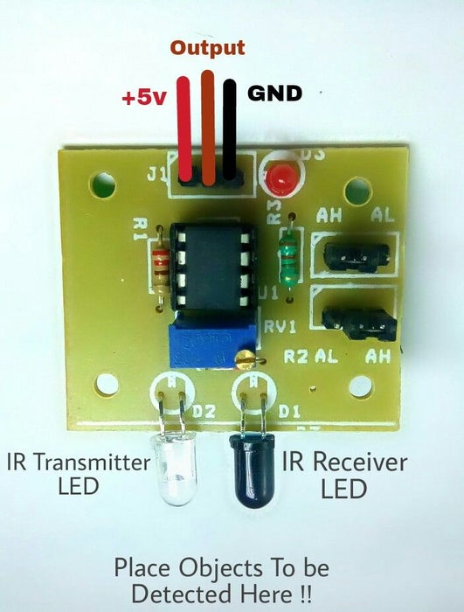

**Specifications**

* Operating Voltage:**3.0V – 5.0V**
* Detection range:**2cm – 30cm (Adjustable using potentiometer)**
* Current Consumption:**at 3.3V : ~23 mA**,**at 5.0V: ~43 mA**
* Active output level: **Outputs Low logic level when obstacle is detected**
* On board Obstacle Detection LED indicator

**IR Transmitter**

* Infrared Transmitter is a light emitting diode (LED) which emits infrared radiations. Hence, they are called IR LED’s. Even though an IR LED looks like a normal LED, the radiation emitted by it is invisible to the human eye.

**IR Receiver**

* Infrared receivers are also called as infrared sensors as they detect the radiation from an IR transmitter. IR receivers come in the form of photodiodes and phototransistors. Infrared Photodiodes are different from normal photo diodes as they detect only infrared radiation. The picture of a typical IR receiver or a photodiode is shown below.

**Working Principle of IR Obstacle Sensor**

An IR sensor consists of an IR LED and an IR Photodiode; together they are called as Photo–Coupler or Opto–Coupler. As said before,the Infrared Obstacle Sensor has builtin IR transmitter and IR receiver. **Infrared Transmitter** is a light emitting diode (LED) which emits infrared radiations. Hence, they are called IR LED’s. Even though an IR LED looks like a normal LED, the radiation emitted by it is invisible to the human eye. **Infrared receivers** are also called as infrared sensors as they detect the radiation from an IR transmitter. IR receivers come in the form of photodiodes and phototransistors. Infrared Photodiodes are different from normal photo diodes as they detect only infrared radiation. When the IR transmitter emits radiation, it reaches the object and some of the radiation reflects back to the IR receiver. Based on the intensity of the reception by the IR receiver, the output of the sensor is defined.

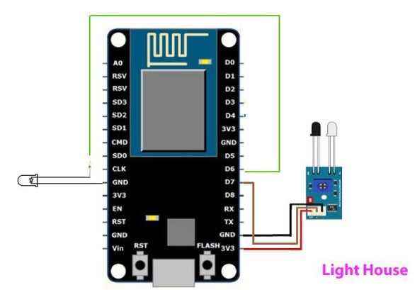

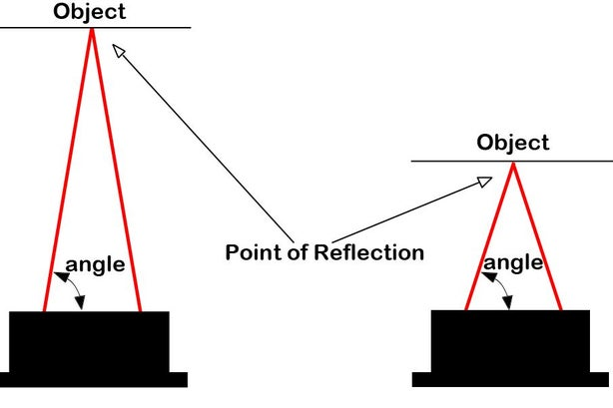

**Program for IR Obstacle Sensor**

[](https://wiki.eprolabs.com/index.php?title=File:IR_obstacle_sensor.jpg)

Upload the program given below to your nodemcu board.The on-board obstacle led will turn on when is there any obstacle exist in front of sensor.It will turn off when there is no obstacle.

int irObstaclePin = 7; // This is our input pin

int Obstacle = HIGH; // HIGH MEANS NO OBSTACLE

void setup()

{

pinMode(irObstaclePin, INPUT);

Serial.begin(9600);

}

void loop()

{

Obstacle = digitalRead(irObstaclePin);

if (Obstacle == LOW)

{

Serial.println("OBSTACLE!!, OBSTACLE!!");

}

else

{

Serial.println("clear");

}

delay(200);

}

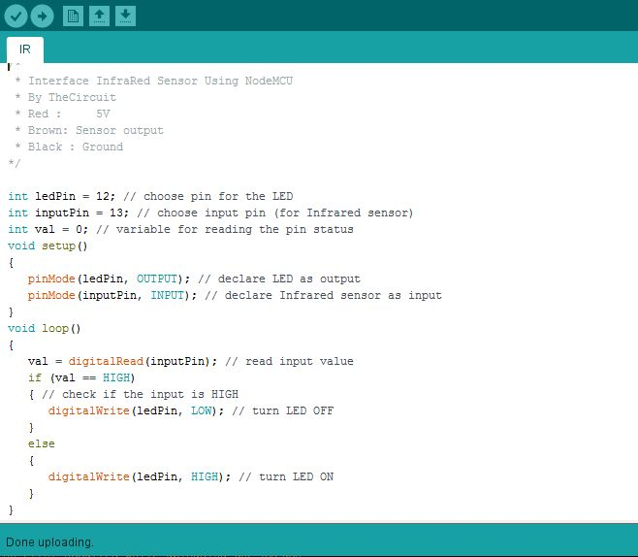

REGARDS:

NARSIMHA REDDY

DHEERAJ T

RAGASRI Y